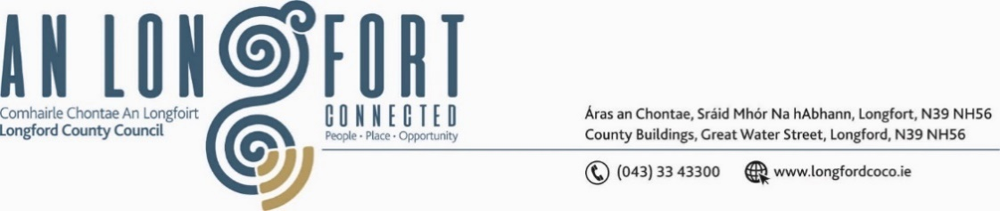

**LONGFORD MUNICIPAL DISTRICT**

**Minutes of 2024 Annual Meeting of Longford Municipal District held in the Council Chamber, Aras an Chontae, Longford on Monday, 24 June 2024 at 3:00 p.m.**

**CATHAOIRLEACH**: Councillor Seamus Butler

**MEMBERS PRESENT**: Councillors Seamus Butler, Martin Monaghan, Kevin Hussey, Peggy Nolan, Niall Gannon, Gerry Hagan, Uruemu Adejinmi

**IN ATTENDANCE:**  Mr. Paddy Mahon, Chief Executive.

Mr. Michael Nevin, Director of Services.

Ms. Helena Heaney,

Ms. Lorraine McKee, Administrative Officer

Mr. John Brannigan,

**APOLOGIES:** None

**MEETINGS**

**ADMINISTRATOR**: Ms. Claire McNabola

**ELECTION OF CATHAOIRLEACH.**

It was proposed by Councillor Martin Monaghan and seconded by Councillor Uruemu Adejinmi that Councillor Seamus Butler be elected Cathaoirleach of Longford Muncipal District

**As there was no other nomination**, **Councillor Seamus Butler was, thereby, elected Cathaoirleach of Longford Municipal District until the Annual Meeting in 2025.**

The Chain of Office was formally conferred on Councillor Seamus Butler by the Chief Executive.

**ELECTION OF LEAS CATHAOIRLEACH:**

It was proposed by Councillor Kevin Hussey and seconded by Councillor Martin Monaghan that Councillor Uruemu Adejinmi be elected Leas Cathaoirleach.

**As there was no other nomination**, **Councillor Uruemu Adejinmi was, thereby, elected Leas Cathaoirleach of Longford Municipal District until the Annual Meeting in 2025.**

**NOMINATION TO COMMITTEES – REFERRED FROM LONGFORD COUNTY COUNCIL 2024 ANNUAL MEETING**

Noted – Agreed at the Annual Meeting of Longford County Council, held on Friday, 21 June 2024

**DATE AND TIME OF LONGFORD MUNICIPAL DISTRICT MEETINGS**

It was agreed at the meeting that Longford Municipal District meetings will be held on the fourth Tuesday of each month at 11am.

The MD Standing Orders will be updated to reflect the Council Standing Orders which were adopted at the AGM on 21 June 2024.  They will reflect the date and time of the meetings agreed at today's AGM.  Provision will be made, in the Standing Orders, for meetings to be held as follows -

* In the Council Chamber, Aras an Chontae.
* Or a suitable external venue, in the Municipal District, used to accommodate meetings of the Municipal District.
* One or more Council buildings or rooms, linked remotely.
* An electronic, digital or virtual location, web address or a conference call telephone number.
* A combination of the above to provide for physical and/or remote attendance by Elected Members.

The updated Standing Orders will be presented at the July Municipal District meeting for formal adoption.

This concluded the business of the meeting.

**Signed: ____________**

**Claire McNabola,**

**Meetings Administrator.**

**Confirmed and adopted at the Longford Municipal District Meeting held on the**

**23 July 2024.**

**Signed: _______________**

**Cathaoirleach.**